**E-Business Project Documentation**

**Date: 19-05-2017**

**Subject Code: CP5310**

**Subject Name: E-Business Technologies**

**Submitted by: Anjoe Jose, Prashanth Subramanian, Satnam Singh, Tony Sabu**

**Student Id: 13297417, 13263581, 13263095, 13306358**

**Professor’s Name: Mr. Timothy Hart**

# Project objectives

1. A web portal for users to search for hotels, Lodges, Hostels, etc.
2. The search results will be displayed as a list and on a map.
3. The user can see all the properties including hotels, lodges and hostels listed by other users also they will be able to see the properties which are already been in the Google Map.
4. The website has a database that is being updated when a new property is being listed.
5. This portal will be a good market space for owners of living spaces like private hostels and room share to expose their small business to world community at free of cost and it will help them increase their earnings.
6. This website has different portals for the room-seeker and the room owner.

# Web 2.0 features

1. Rich User Experience

The use of Google Map API to show the properties directly makes the user experience dynamic. Because it makes things easier.

1. User as a Contributor

In our website, the user is contributing to the database and that makes them evaluate and review the service.

1. Long Tail

Our website is not a product or by product. Instead it is a service and the revenue will be made only by the continuous use of this service (advertisements, subscription).

1. User Participation

User’s properties and interests are the main source content in our website and hence the web 2.0 feature ‘User Participation’ is present in our proposed service.

# Features Implemented

1. Owner and Surfer log in system
2. Interactive map search
3. Type of Property in categorised list ex: rent house, hotel, lodge

# Features planned but not implemented

1. To make website spanning across the entire country. Due to time constraint, we did it for our home city only.
2. Creating a drop-down marker directly in the map api.

# Potential Improvements:

1. Social Media Sharing
2. Photo support search with high quality
3. Request to more information
4. “Call or Email” now request

# Frameworks and Technologies Adopted:

1. Java
2. Eclipse mars 2
3. MySql
4. Apache Tomcat
5. Javascript Pages
6. Map Api
7. Xml
8. And HTML

# Actual Implementation Schedule:

1. Homepage Design (19/04)
2. Register Page for Login (24/04)
3. Welcome Page (26/04)
4. Landlord Registration (28/05)
5. Importing google map and Api (07/04)
6. Backend Database (11/05)
7. Connecting database and front end (14/05)

# Team Contribution:

1. Front-End page Designs: Anjoe Jose and Satnam Singh (Developed the front-end design pages. delivered the assigned tasks on time)
2. Maps integration: Tony Sabu (Worked for integrating the maps to the front-end page
3. Database creation and integration: Prashanth Subramanian

# Project Setup instructions:

**Step 1: Install JDK (Java SE Development Kit). Follow the instructions:**

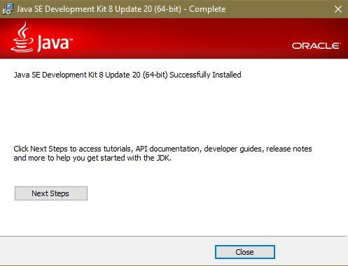

**Step 2: Install and Run Eclipse.exe**

**Step 3: Install Apache Tomcat**

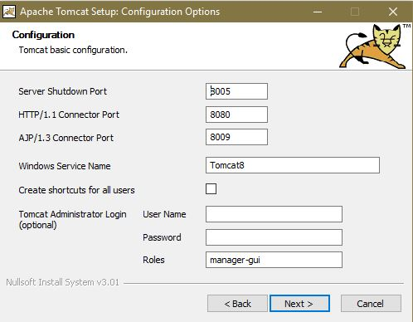

**Step 4 Install MySql Server**

**Step 5: Open MySQL Command Line Client window and enter the password (info123.)**

**Note: - Do not forget to put ‘.’ At the end.**

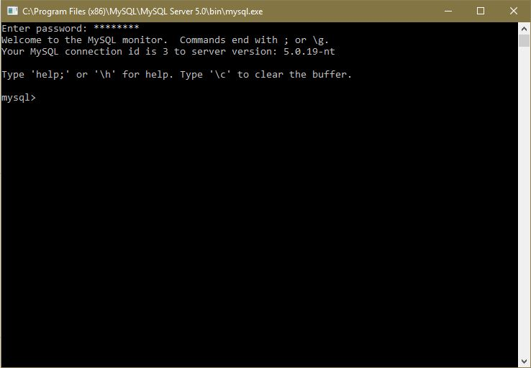

**Step 6: At this stage, open the db(1).sql file in a WordPad or a notepad copy the all contents in the above window.**

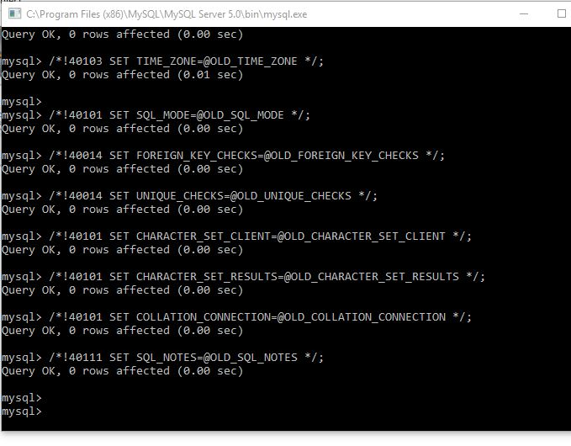

**Step 6: Open Ecplise and import the project.**

**Step 7: Click on window 🡪 Preferences 🡪 server 🡪 runtime environment 🡪 add 🡪 Apache tomcat v8**

**Step 7: In the project explorer tab right click rent-a-space🡪 run as 🡪 run on server**

**Please open the link** <http://localhost:8080/HouseRent/> **on Microsoft edge or Mozilla Firefox browser.**